Optical lattice clocks

Definition:
# Source: AI Source: Provided by: [Data Path: Persons Table -> ID Column: 1, Name_En Column: Motasem Essam] -> From: [ChatGPT] on [1/26/2026]
Optical lattice clocks are the newest and most precise type of atomic clocks. They use lasers and trapped atoms to measure time with extraordinary accuracy, far surpassing traditional cesium clocks.

How optical lattice clocks work
# Source: AI Source: Provided by: [Data Path: Persons Table -> ID Column: 1, Name_En Column: Motasem Essam] -> From: [ChatGPT] on [1/26/2026]
- Trapping atoms in a lattice
  - Neutral atoms (often strontium or ytterbium) are trapped in a grid of laser light called an optical lattice.
  - This keeps the atoms nearly motionless, which reduces measurement errors.
- Using optical frequencies
  - The clock measures oscillations of light waves (hundreds of terahertz) instead of microwave frequencies used in cesium clocks.
  - These optical frequencies are much higher, which allows much more precise time measurement.
- Counting oscillations
  - The clock counts the vibrations of light absorbed/emitted by the atoms.
  - This defines an extremely accurate “tick” for the clock.

Key Features
# Source: AI Source: Provided by: [Data Path: Persons Table -> ID Column: 1, Name_En Column: Motasem Essam] -> From: [ChatGPT] on [1/26/2026]
- Extremely high precision
  - Can measure time with accuracy better than 1 second over billions of years.
- Better than cesium clocks
  - Because optical frequencies are higher than microwave frequencies, the “ticks” are finer and more precise.
- Experimental but advancing fast
  - Already used in labs and considered for the future redefinition of the second.

Common Uses
# Source: AI Source: Provided by: [Data Path: Persons Table -> ID Column: 1, Name_En Column: Motasem Essam] -> From: [ChatGPT] on [1/26/2026]
- Scientific research (fundamental physics, gravitational studies)
- Satellite and space-time experiments
- Next-generation time standards for global timekeeping
- Testing general relativity using time differences at different altitudes

Comparison with other atomic clocks
# Source: AI Source: Provided by: [Data Path: Persons Table -> ID Column: 1, Name_En Column: Motasem Essam] -> From: [ChatGPT] on [1/26/2026]
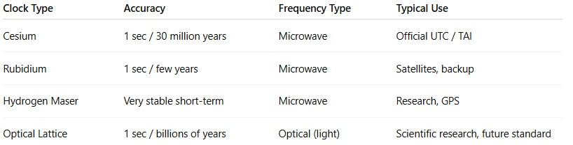
Clock Type | Accuracy | Frequency Type | Typical Use
Cesium | 1 sec / 30 million years | Microwave | Official UTC / TAI
Rubidium | 1 sec / few years | Microwave | Satellites, backup
Hydrogen Maser | Very stable short-term | Microwave | Research, GPS
Optical Lattice | 1 sec / billions of years | Optical (light) | Scientific research, future standard

✅ Summary:
# Source: AI Source: Provided by: [Data Path: Persons Table -> ID Column: 1, Name_En Column: Motasem Essam] -> From: [ChatGPT] on [1/26/2026]
An optical lattice clock is an ultra-precise atomic clock that traps atoms in lasers and measures the vibrations of light, offering accuracy far beyond traditional cesium clocks and paving the way for the future of global timekeeping.

